# Problem



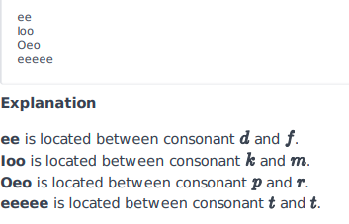

# Solution

# Enter your code here. Read input from STDIN. Print output to STDOUT

s = input()

#https://codereview.stackexchange.com/questions/240862/regular-expressions-finding-two-or-more-vowels-with-a-consonant-before-and-aft

import re

matches = re.findall(r'(?<=[qwrtypsdfghjklzxcvbnm])([aeiou]{2,})(?=[qwrtypsdfghjklzxcvbnm])', s, re.IGNORECASE)

if matches:

    for match in matches:

        print(match)

else:

    print(-1)